LAPORAN TUGAS
WORKSHOP SISTEM INFORMASI WEB SERVER
(TIF330805)
MINGGU KE-2 Pertemuan 2
SEMESTER III



ACARA 4
PHP Native View, Layout, dan Dasar OOP

Disusun Oleh :

Rezza Wahyu Setya Adhy (E41250211)
Golongan A

PROGRAM STUDI DI LUAR KAMPUS UTAMA (PSDKU)
TEKNIK INFORMATIKA KAB. NGANJUK
JURUSAN TEKNOLOGI INFORMASI
POLITEKNIK NEGERI JEMBER
TAHUN 2026
- Studi Kasus
Setiap halaman aplikasi biasanya punya header (logo, menu) dan footer (copyright) yang sama. Jika Anda copy-paste header ke 20 file, ketika menu berubah Anda harus edit 20 files. Dengan partial + include, Anda hanya edit satu file.
- Tujuan
Mahasiswa membuat layout dengan partial, membuat class Mahasiswa sederhana, dan menampilkan data dari object di View.
- Langkah
- Buat folder partials dan layouts.
- Buat header.php, navbar.php, footer.php.
- Buat class Mahasiswa dengan property private + getter.
- Di index.php (sementara), buat beberapa object Mahasiswa dan kirim ke View.
- Tampilkan data dalam tabel Bootstrap.
- Proses
- Struktur Folder
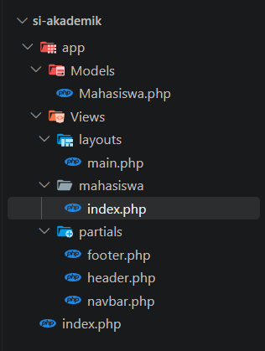
- app/Views/partial/header.php
<header class="bg-dark text-white text-center py-3">
<h4 class="m-0">Sistem Informasi Data Mahasiswa</h4>
<small>Acara 4 - PHP Native View, Layout, dan Dasar OOP</small>
</header>
- app/Views/partial/navbar.php
<nav class="navbar navbar-expand-lg navbar-light bg-light border-bottom">
<div class="container-fluid">
<a class="navbar-brand" href="#">TIF - Politeknik Negeri Jember</a>
<div class="collapse navbar-collapse">
<ul class="navbar-nav me-auto">
<li class="nav-item">
<a class="nav-link active" href="index.php">Data Mahasiswa</a>
</li>
</ul>
</div>
</div>
</nav>
- app/Views/partial/footer.php
<footer class="bg-dark text-white text-center py-3 mt-4">
<small>&copy; <?= date('Y') ?> - BKPM Workshop SI Web Server (TIF330805)</small>
</footer>
- app/Models/Mahasiswa.php
<?php

namespace App\Models;

class Mahasiswa
{
private string $nim;
private string $nama;
private string $prodi;

public function __construct(string $nim, string $nama, string $prodi)
{
$this->nim = $nim;
$this->nama = $nama;
$this->prodi = $prodi;
}

public function getNim(): string { return $this->nim; }
public function getNama(): string { return $this->nama; }
public function getProdi(): string { return $this->prodi; }

public function setNama(string $nama): void
{
if (strlen($nama) < 3) {
throw new \InvalidArgumentException("Nama terlalu pendek");
}
$this->nama = $nama;
}

public function getLabel(): string
{
return "{$this->nim} - {$this->nama} ({$this->prodi})";
}
}
- index.php
<?php
require_once __DIR__ . '/app/Models/Mahasiswa.php';

use App\Models\Mahasiswa;

$daftarMahasiswa = [
new Mahasiswa("2401001", "Axel Wangsa", "Teknik Informatika"),
new Mahasiswa("2402001", "Yogian Eriya", "Sistem Informasi"),
new Mahasiswa("2501078", "Rezza Hebat", "Teknik Informatika"),
];

$content = __DIR__ . '/app/Views/mahasiswa/index.php';
require __DIR__ . '/app/Views/layouts/main.php';

- app/Views/layouts/main.php
<!DOCTYPE html>
<html lang="id">
<head>
<meta charset="UTF-8">
<title>Data Mahasiswa - Acara 4</title>
<link rel="stylesheet" href="https://cdn.jsdelivr.net/npm/bootstrap@5.3.3/dist/css/bootstrap.min.css">
</head>
<body>
<?php include __DIR__ . '/../partials/header.php'; ?>
<?php include __DIR__ . '/../partials/navbar.php'; ?>
<main class="container mt-4">
<?php require $content; ?>
</main>
<?php include __DIR__ . '/../partials/footer.php'; ?>
</body>
</html>

- app/Views/mahasiswa/index.php
<h5 class="mb-3">Daftar Mahasiswa</h5>

<table class="table table-bordered table-striped align-middle">
<thead class="table-dark">
<tr>
<th>No</th>
<th>NIM</th>
<th>Nama</th>
<th>Program Studi</th>
<th>Label</th>
</tr>
</thead>
<tbody>
<?php foreach ($daftarMahasiswa as $i => $mhs): ?>
<tr>
<td><?= $i + 1 ?></td>
<td><?= htmlspecialchars($mhs->getNim()) ?></td>
<td><?= htmlspecialchars($mhs->getNama()) ?></td>
<td><?= htmlspecialchars($mhs->getProdi()) ?></td>
<td><?= htmlspecialchars($mhs->getLabel()) ?></td>
</tr>
<?php endforeach; ?>
</tbody>
</table>
- Output
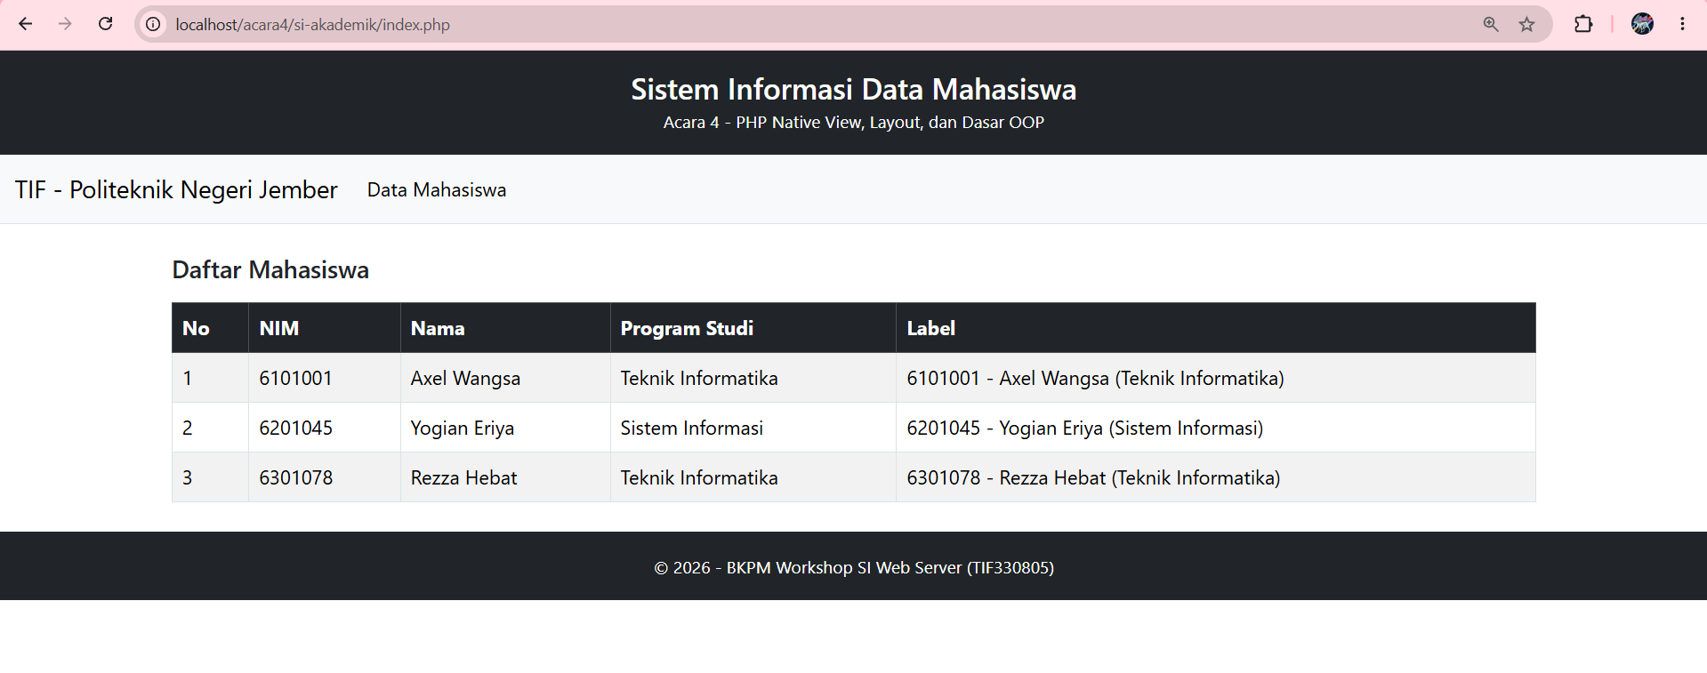
- Tugas Mandiri
Tambahkan method di class Mahasiswa yang mengembalikan angkatan berdasarkan 2 digit awal NIM (asumsi format NIM tertentu). Tampilkan di View.
- Proses :
- Menambahkan code di app/Views/Mahasiswa.php
<h5 class="mb-3">Daftar Mahasiswa</h5>

<table class="table table-bordered table-striped align-middle">
<thead class="table-dark">
<tr>
<th>No</th>
<th>NIM</th>
<th>Nama</th>
<th>Program Studi</th>
<th>Angkatan</th>
<th>Label</th>
</tr>
</thead>
<tbody>
<?php foreach ($daftarMahasiswa as $i => $mhs): ?>
<tr>
<td><?= $i + 1 ?></td>
<td><?= htmlspecialchars($mhs->getNim()) ?></td>
<td><?= htmlspecialchars($mhs->getNama()) ?></td>
<td><?= htmlspecialchars($mhs->getProdi()) ?></td>
<td><?= htmlspecialchars($mhs->getAngkatan()) ?></td> <td><?= htmlspecialchars($mhs->getLabel()) ?></td>
</tr>
<?php endforeach; ?>
</tbody>
</table>
- Menambah code di app/Models/mahasiswa/index.php
<?php

namespace App\Models;

class Mahasiswa
{
private string $nim;
private string $nama;
private string $prodi;

public function __construct(string $nim, string $nama, string $prodi)
{
$this->nim = $nim;
$this->nama = $nama;
$this->prodi = $prodi;
}

public function getNim(): string
{
return $this->nim;
}

public function getNama(): string
{
return $this->nama;
}

public function getProdi(): string
{
return $this->prodi;
}

public function setNama(string $nama): void
{
if (strlen($nama) < 3) {
throw new \InvalidArgumentException("Nama terlalu pendek");
}
$this->nama = $nama;
}

public function getLabel(): string
{
return "{$this->nim} - {$this->nama} ({$this->prodi})";
}

public function getAngkatan(): string
{
$duaDigitAwal = substr($this->nim, 0, 2);

if (strlen($duaDigitAwal) < 2 || !ctype_digit($duaDigitAwal)) {
return "Tidak diketahui";
}

return "20" . $duaDigitAwal;
}

}

- Output
